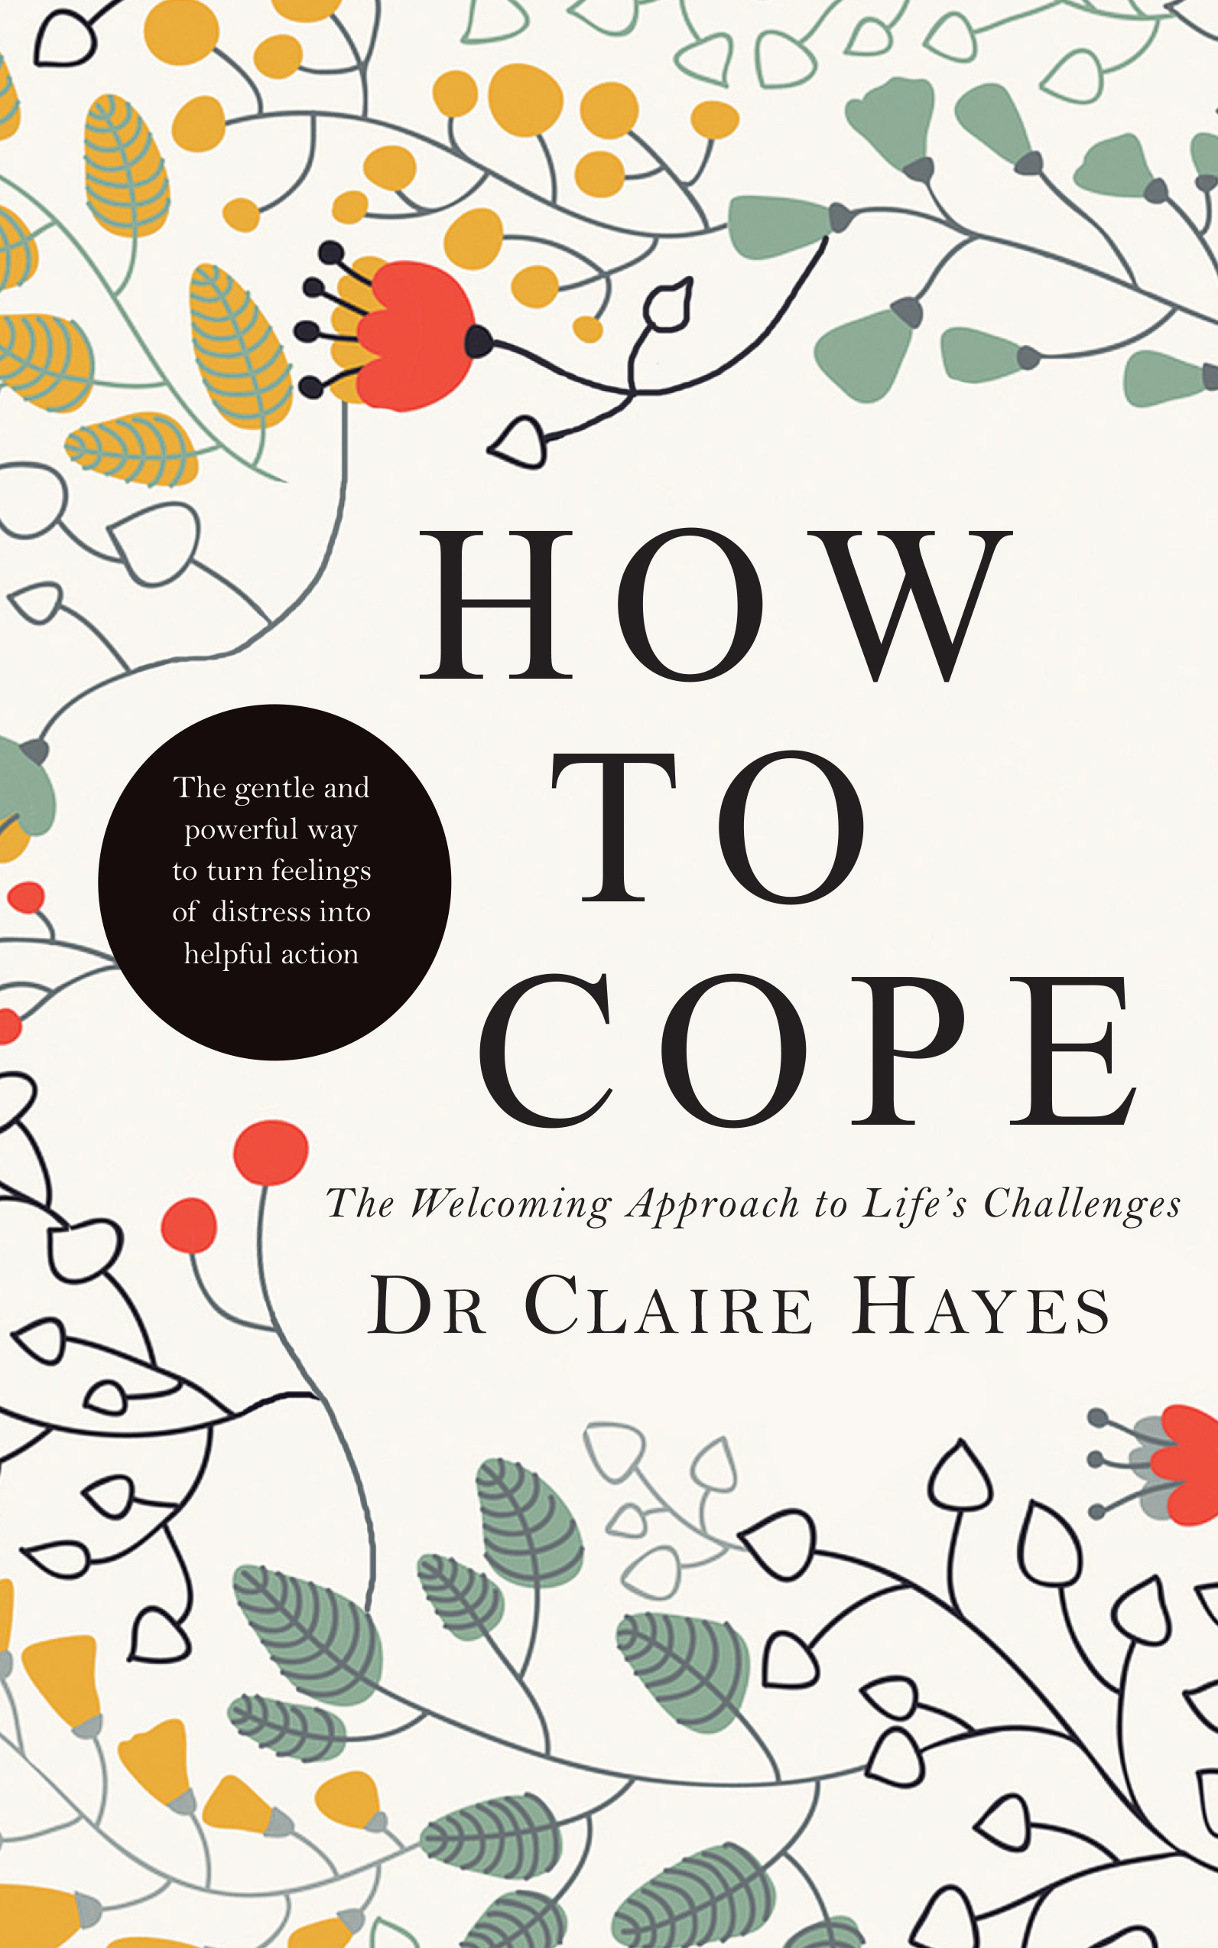
HOW TO COPE
The Welcoming Approach to Life’s Challenges

Dr Claire Hayes

Published Wednesday, 22 April 2015

The gentle and powerful way to turn feelings of distress into helpful action

‘Life can be demanding enough without us causing ourselves greater upset because we ‘don’t feel happy’. Instead, let’s welcome all our feelings of distress, all of our thoughts and beliefs, and focus on transforming these in a way that is helpful for us.’

Dr Claire Hayes is Clinical Director of Aware and has also run her own private practice for many years. In her remarkable new book, How to Cope: The Welcoming Approach to Life’s Challenges, she demonstrates how each of us can use cognitive behavioural principles to help us cope. In a very clear, practical way she shows us how to make sense of our distressing feelings, to become aware of our unhelpful thoughts and most of all, how to focus on what we can actually do to improve things for ourselves. Rather than trying to supress or ignore our feelings of distress, she invites us to welcome them as messengers telling us that all is not well and asking us to do something helpful.

The World Health Organisation predicts that by 2030 depression will be the number one global burden of disease. How to Cope is aimed at stopping this from becoming a self-fulfilling prophecy. It is for anyone struggling with the stress and anxiety that can arise from coping with life’s universal challenges including pressure, rejection, failure, success and change. A range of case studies, devised for this book, but similar to issues that any of us can face, illustrate the success of Dr Hayes’ approach, while practical exercises and advice make it accessible to all readers, empowering them to take positive action to manage life’s challenges.

Dr. Claire Hayes is the Clinical Director of Aware and also runs her own private practice. She has a keen interest in applying cognitive behavioural principles to her work with individuals and organisations. She has over twenty years’ training and experience as a clinical psychologist, educational psychologist, an executive coach, lecturer, author, researcher and teacher.


How to Cope: The Welcoming Approach to Life’s Challenges will be launched at Croke Park by Aogán Ó Fearghaíl, President of the GAA, on Wednesday 22 April 2014, priced at €14.99. For further information, please contact Teresa Daly, Communications Manager, Gill & Macmillan, 01 500 9521, 086 838 3559, tdaly@gillmacmillan.ie.

